Mehmet Izol

Professor Cleveland

COMP 3324-1 Computer Networks

Week 4 – Lab 1 – Using Burp for penetrating

February, 28, 2023

**Burp penetrating testing of web applications**

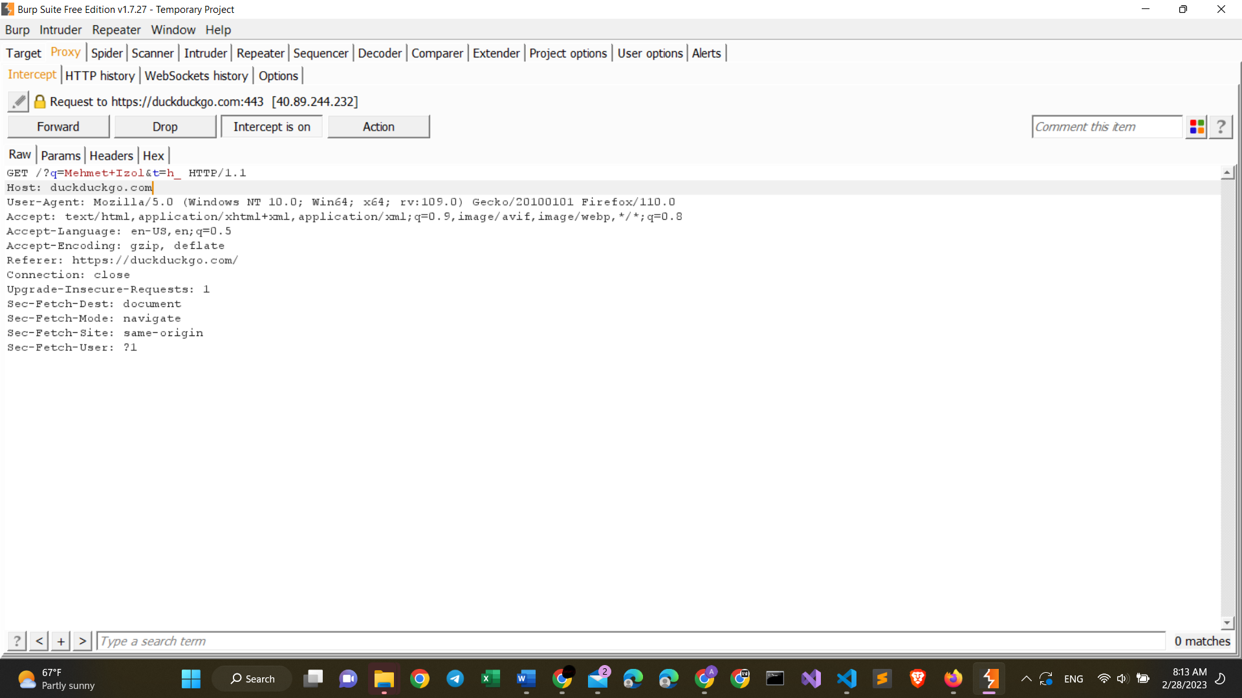

Proj 3a from Mehmet Izol

**Intercepting an encrypted login**

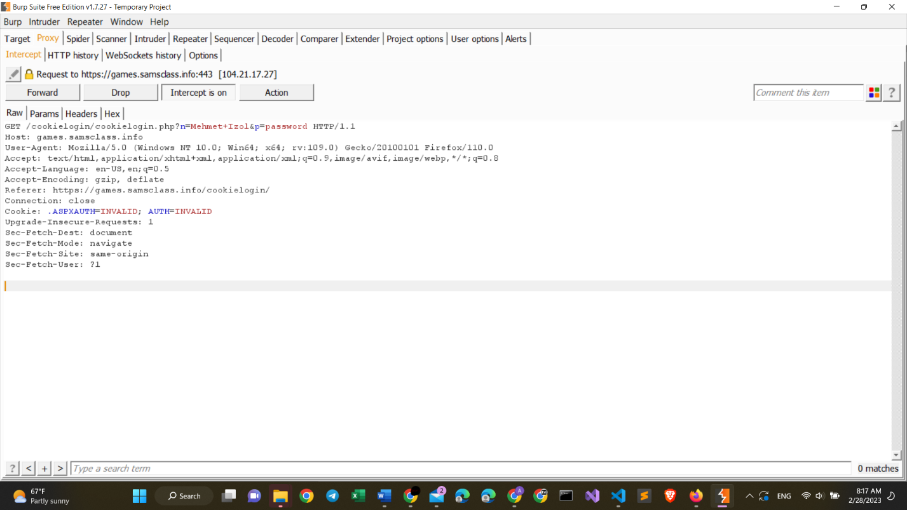

Proj 3b from Mehmet Izol

**Using Burp site map**

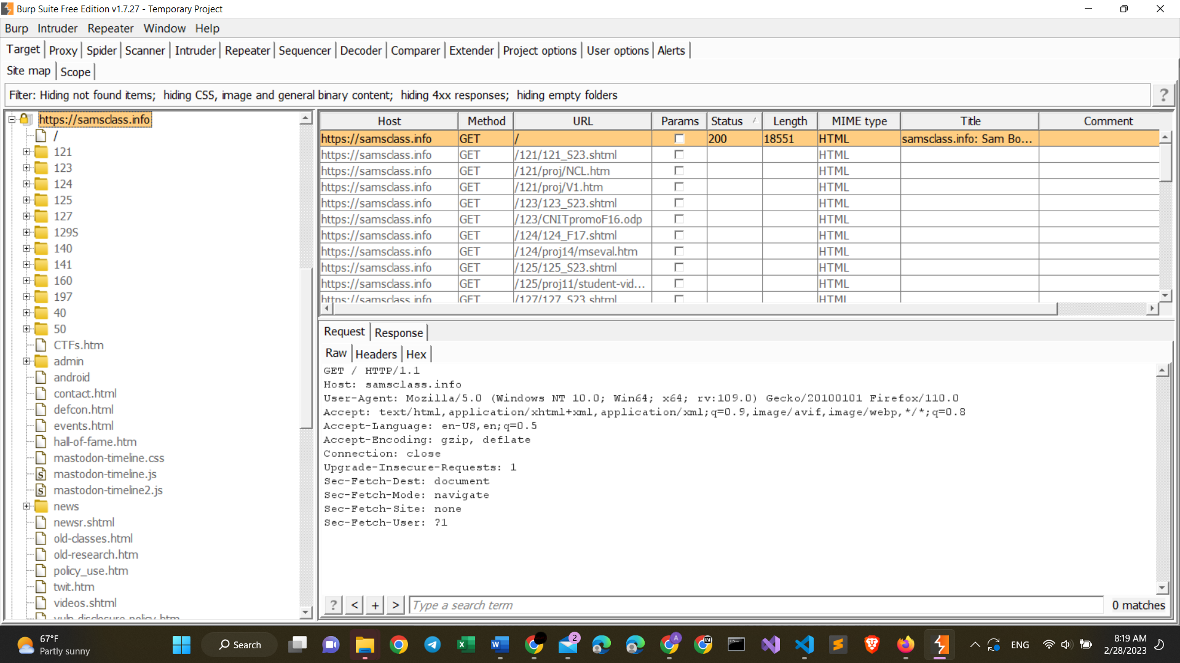

Proj 3c from Mehmet Izol

What new I learned with Burp

+ first, bing.com did not work, when trying to perform the first penetrating with my name. But, my friend told me to try to use duckduckgo.com.

+ So, it worked, and have uploaded the image pretty well.

+ Second, some sites, like bing.com and samsclass.info did not work at first. So, I changed bing to duckduckgo, and samsclass.info I wrote without the https:, and then it worked very finely.

+ Finally, it is pretty obvious, that these applications like burp can receive our information very easily, and we need to be very cautious, when giving access to unknown sources.

+also, my friend advised me to use an older version of burp, like the same with the version on the requirements. Version 1.7.27.